**COMP S350F Soware Engineering**

**Testing plan report**

Li Wing On S1288646

Cheng Kwing To S1288927

Ieong Kai Yip S1331448

**Validation test:**

-Login interface where user login to use the system:

-there are three types of menus for users:

-student:

-teacher:

-admin:

For the user function, all users can view and update personal information and change the password. Apart from the common function, student can only view their own academic records while teacher can view and update the information of all students he taught. The admin has the highest level of access, he can view all the courses and information over teacher and student and make changes of it.

**Successful test:**

-view personal information and update the new username and password as 123:

-student viewing enrolled course:

-student viewing grades:

-student viewing attendance:

-teacher viewing student information:

-teacher updating student’s grade of course C02 as “A”:

-teacher updating student’s course as “C01”:

-admin creating a new student user with username “s1234567” and password “12345678”:

-admin deleting user of username “student1”:

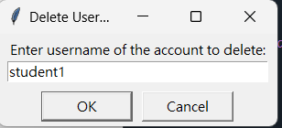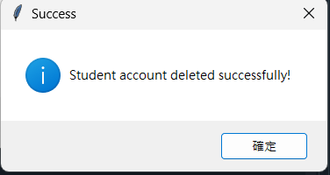

**Defect testing:**

In the function of “view all student’s information”, we can successfully display three example students. However, in the reality, a normal class usually consists of over thirty students and once we enter thirty student users into the system and use the function, it can only show 23 users’ information in the chat box. This is because the chat box only shows the information horizontally and it cannot scroll upward downward to see the remaining information. It has upper limit depends on the computer’s length. Thus, the defect of the system is the function of “view all student’s information” cannot show all students’ information when the student user over 23. The solution of this defect can be using a table format to display student’s information instead of using a chat box.

-successful test:

